Table of Contents
1. Introduction 2
1.1 Problem Scenario 3
1.2 Propose Solution 4
2. Aims and Objectives 4
2.1 Aim 4
2.2 Objectives 5
3. Outcomes and Deliverables 5
3.1 Project Documentation and Artifacts 6
4. Project risks and threats 6
5. Work Breakdown Structure 7
6. Technology Stack Justification 7
6.1 Frontend 7
6.2 Backend 7
6.3 Data tier 8
7. Project Gantt Chart 8
8. Conclusion 9
9. References 10

Introduction
The process of attracting top talent and competent employees in these days is definitely becoming increasingly difficult. Recruiters and managers attribute it to the nature of the labor pool and high number of job seekers hence are not skilled enough. However, that is just part of a multidimensional issue: the actual competition could be your online job application. (wolfe, 2025)
The repeated update of emails, re-reading job description, updrafting and re-deleting follow up emails etc. It is tiresome, irritating, even harmless.The employment screening process is one of the most tedious periods that one might go through when seeking a job. Regardless of the level of industry or job role, at some point or another, you are going to get no responses to a job application.
This can be hard to take. The natural response to this is to doubt your ability, experience and general capabilities to handle the job without any kind of closure and it is difficult to not Take rejection personally. (tips, 2024)
Hence, I decided to make the app Connecto which solves all these problems and makes job hunting actually fun and less tiresome for both the recruiter and applicants.

Problem Scenario
In a recent study, 88.7 percent of potential candidates fail to see out the process to completion by companies that require 45 or more fields to fill in on an application. In case 45 does not sound like so much, then take into consideration that the typical application of an average company in the Fortune 500 has 62.8 questions and it takes an average of 52 minutes to fill in. (wolfe, 2025)
The existing job portals and recruitment systems are highly frictional, lack efficiency and heavily depend on high volume, low quality applications. To candidates, it is consuming of time in formatting resumes, writing specific cover letters, and little or no response, which frequently leads to application fatigue. To recruiters, the problem is that it is difficult to sort through hundreds of irrelevant applications (low application-to-interview ratio) and thus the hiring process is slowed down and the administration is overloaded. The fundamental shortcoming is the absence of a contemporary, expedited, and proficient matching engine with relevance and promptness in place of the conventional parsing of documents. The market determines the necessity of a mobile-first solution that brings principles of gamification to make the process of talent acquisition less effortful and with higher signal-to-noise ratio.

Propose Solution
The Connecto platform addresses these deficiencies by offering a next-generation mobile application that fundamentally redesigns the job search and recruitment workflow. Our solution is centered on three core innovations:
- Swipe-Based Interface:
Replacing long forms and keyword searches with a fast, intuitive swipe gesture (right for interested, left for reject), reducing candidate effort to seconds per job card.
- Smart matching algorithm:
Utilizing a proprietary algorithm built in .NET that calculates job relevance based on a strict, weighted match between the Candidate’s profile skill tags and the Job’s required skill tags , thereby ensuring high-quality matches.
- Recruiter Visibility Guarantee:
Implementing real-time push notifications to instantly alert recruiters to new applications, drastically improving response times and reducing recruiter fatigue.

Aims and Objectives

Aim
The overarching aim of this project is to develop and evaluate a robust, mobile job matching application named Career that successfully leverages gamification and a skill-based matching algorithm to significantly enhance efficiency and relevance in the candidate-recruiter interaction.

Objectives
The objectives behind this project are:
- To simplify recruiter and applicant interaction.
- To make job hunting actually fun and less tiresome
- To design and implement an app that handles swipe based mechanism and card rendering
- To successfully implement real time notification logic to gurantee instant alert to both recruiter and applicants regarding the status.

Outcomes and Deliverables
After the completion of the project, following modules can be expected:
- Mobile Profile Management
- React Native UI for creating/editing detailed, skill-based user profiles.

- Gesture Based Matching
- Swipe-to-Apply mechanism for efficiently viewing and acting on job cards.

- Smart Job Feed
- Real Time feed shown by the smart matching Algorithm.

- Job Listing Creation
- Secure mobile interface for posting new job requirements, specifying required skills, and location.

- Application Review Dashboard
- Dedicated dashboard to view a list of candidates who have applied to their listings.

- Real Time Notification
- Push notification system for mutual matches and new applications (Recruiter).

Project Documentation and Artifacts
- Final Report: Comprehensive document detailing the design, implementation, evaluation, and future scope.
- Software Requirements Specification (SRS): Detailed document defining all functional and non-functional requirements.
- GANTT Chart / WBS: The finalized project schedule used for task tracking and time management.
- Technical Artifacts: The final Database Schema (ERD) and all necessary schema creation scripts.
- Source Code: Complete, well-commented, and version-controlled source code repository for all layers.

Project risks and threats
Risk Category | Description | Severity
Technical Complexity | The Smart Matching Algorithm requires complex C# logic for skill-tag weighting and relevance scoring. | High
Resource Dependency | Steep learning curve associated with React Native and its specific dependencies/debugging challenges. | High
Integration Failure | Potential difficulty integrating the stateful React Native client with the RESTful .NET API, particularly with real-time notifications . | Medium

Methodology
The project will employ the Incremental Development Model, which is a highly effective methodology under the Agile umbrella. This choice is based on the project’s inherent complexity, requiring early validation of key features and complex integration across three distinct technical tiers (React Native, .NET API, and MySQL).
The Incremental Model is justified for the Connecto project because it allows us to:
- Prioritize Core Functionality: The initial increments focus exclusively on developing and unit testing the robust backend foundation, including the database and the core Smart Matching Algorithm. This ensures that the most critical, high-risk business logic is functional and stable before engaging the mobile front-end.

- Mitigate Integration Risk: Development is phased to tackle integration challenges logically. For example, the backend API is completed first, providing stable endpoints for the front-end to consume. The client-side (React Native) is then built in subsequent increments (e.g., Profile UI, then Swipe Component, then Dashboard), allowing for early testing of the critical Swipe-to-Apply mechanism.

- Deliver Early and Testable Value: The iterative nature of this approach means that each completed phase delivers a functional, testable subset of the overall system. This structure supports the need for continuous stakeholder (supervisor) review, testing, and mid-course correction, providing flexibility and alignment with best practice Agile development cycles. This is crucial for verifying the accuracy of the proprietary matching algorithm and the usability of the mobile UI.

Work Breakdown Structure
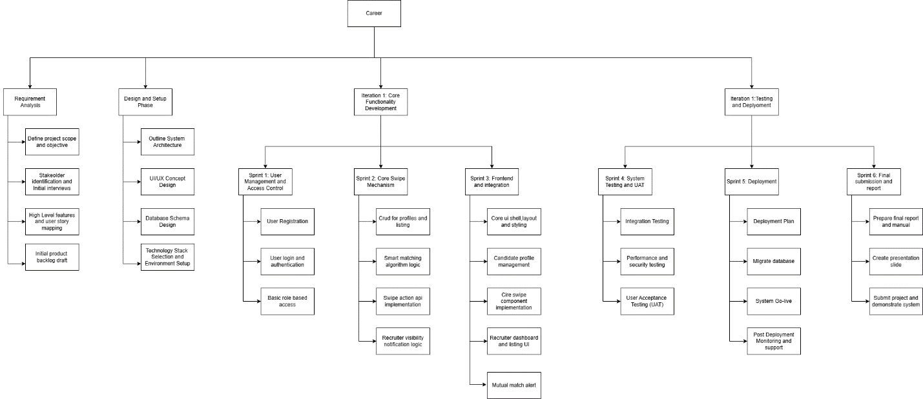
Figure 1 FYP WBS

Technology Stack Justification

Best-in-class, cross-platform technologies have been used to organization of the three tier architecture, to make it scalable, maintainable, and high performance.

Frontend
- Technology: React Native
- Justification: Chosen specifically to deliver a native mobile user experience for the crucial gesture-based swipe UI. React Native provides a single codebase for high-performance mobile deployment, which is essential for the smooth, low-latency interaction required by the gamified experience.

Backend
- Technology: .NET Core / C#
- Justification: .NET Core is a robust, high-performance, and cross-platform framework, making it the ideal choice for hosting the RESTful API. C# is perfectly suited for implementing and efficiently executing the complex, proprietary Smart Matching Algorithm business logic.

Data tier
- Technology: MySQL
- Justification: A mature, reliable, and high-performance open-source Relational Database Management System (RDBMS). MySQL is suited for handling the structured, high-volume transactional data (User accounts, Job Listings, and the constantly growing Swipe Action log) that is central to the application's functionality.

Project Gantt Chart
A Gantt chart is a project management chart that allows project managers to create a project schedule. It shows the order in which project tasks will be completed, when they’re due, their duration among other details. (manager, 2024)
The Gantt of the project is developed according to the Scrum concept of developing software in which the project activities are split into numerous sprints. The project is approximated to be completed within a period of five months, until the end of the month of April, 2025.
The Gantt chart of this project is given below:
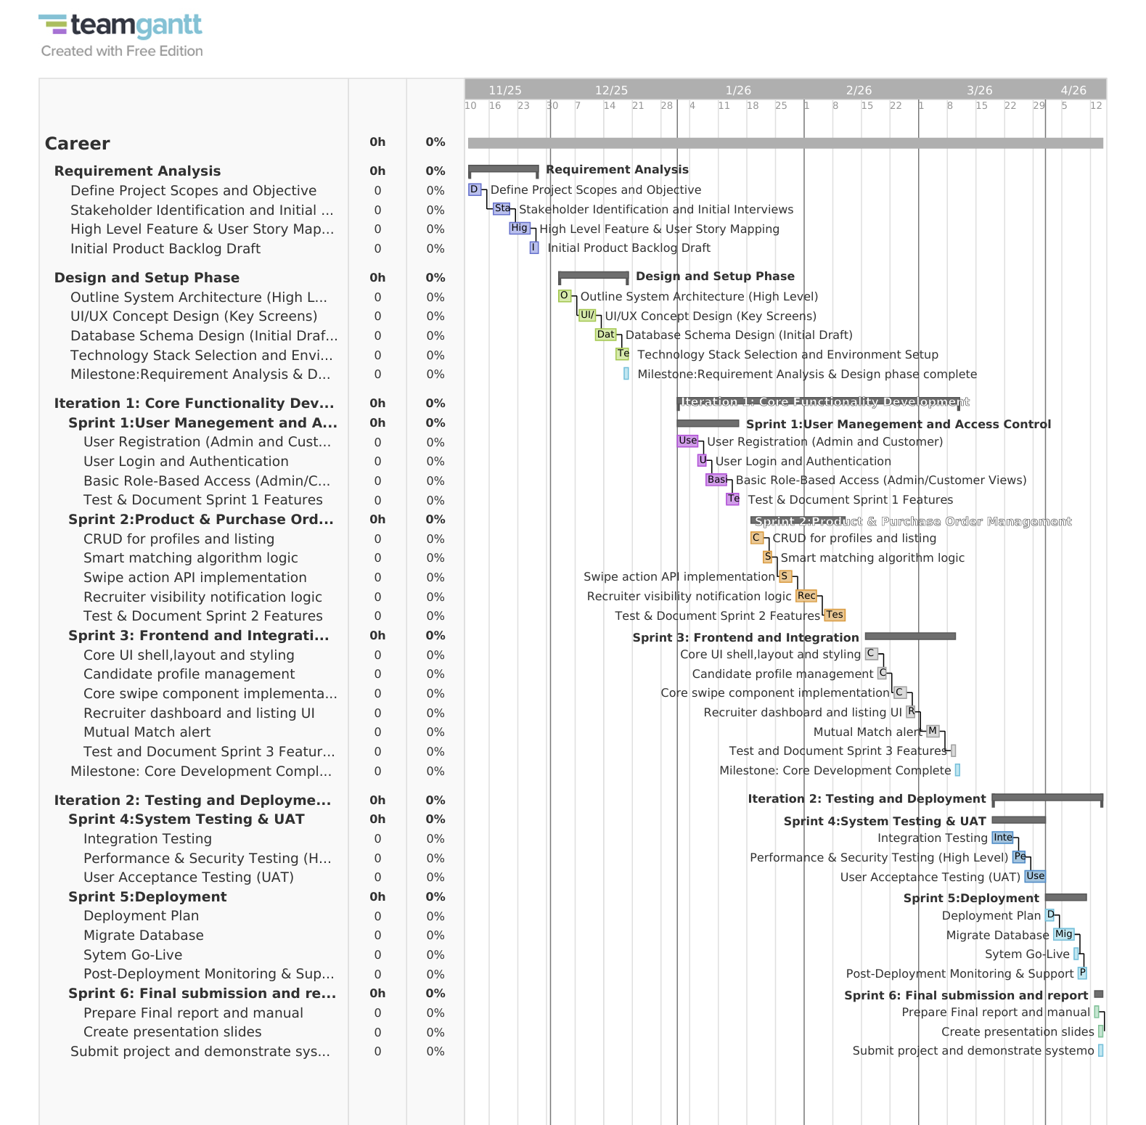
Figure 2 FYP ganttchart

Conclusion
The Career project presents a challenging, yet highly relevant, solution to the documented inefficiencies in modern recruitment. By adopting a mobile-first approach with React Native and utilizing a powerful, customized matching algorithm in .NET, the system promises to deliver a uniquely efficient and engaging user experience.

References
manager, p. (2024) project manager [Online]. Available from: https://www.projectmanager.com/guides/gantt-chart [Accessed 15 November 2025].
tips, j. (2024) Explore UE [Online]. Available from: https://www.ue-germany.com/blog/10-reasons-why-your-job-application-is-not-getting-a-response [Accessed 15 november 2025].
wolfe, I.S. (2025) cornerstone [Online]. Available from: https://www.cornerstoneondemand.com/resources/article/4-common-failures-online-job-applications-and-how-fix-them/ [Accessed 15 November 2025].

